MONDAY 18TH MARCH 2019
Published on Monday, March 18, 2019

Airbnb loses key legal challenge in Santa Monica
Home sharing platforms Airbnb and HomeAway suffered a legal setback in Santa Monica which could spell problems in other cities around the country.
Their legal bid to overturn a Santa Monica ordnance was denied by the Court of Appeals, which means the companies are on the hook for illegal listings on their websites.
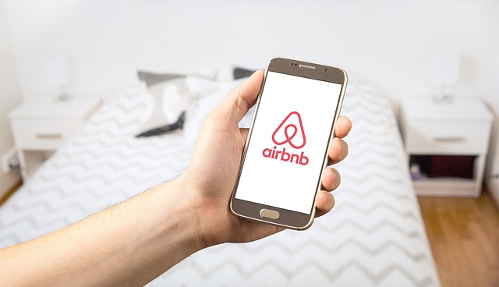
The ordinance makes Airbnb and HomeAway responsible for any unlicensed rentals listed online.
They cited the U.S. Communications Decency Act of 1996, which protects websites from liability for the content posted by users.
Airbnb and HomeAway argued it would be virtually impossible for them to operate as they would be required to continually monitor and remove listings.
"We are thrilled to have confirmation from the 9th Circuit that our balanced approach to home sharing is working at a time when housing and affordability continue to challenge the region," Mayor Gleam Davis said, adding it is a 'big win' for residents.
HomeAway owner Expedia said the court decision is out of step with other rulings which have interpreted the Communications Decency Act differently.
The decision could have ramifications around the country with the American Hotel & Lodging Association lauding it as a 'historic victory.'
The AHLA said it will likely encourage other cities to pass similar laws.

