Are 1,818 Airbnbs Too Many in Joshua Tree? NY Times
A short-term rental gold rush is fueling concern for the area’s signature trees and debates about whether the nature of life in the desert of southeastern California is changing forever.
A new short-term rental property in Joshua Tree, Calif. Two years ago Somewhere, a property development company, bought this piece of land for $40,000. The listing is now renting for $1,031 a night.Credit...Cody James for The New York Times

By Heather Murphy Published April 7, 2022Updated April 8, 2022
For the last six years, the 10-acre Desert Yacht Club — a 1946 Chris Craft cruiser anchored on a rocky hilltop amid retro trailers near Joshua Tree, Calif. — has been Alessandro Giuliano’s primary source of inspiration, social interaction and income. The off-the-grid glamping site has appeared in the Italian version of Rolling Stone, on lists of epic luxury camping experiences and in films. Mr. Giuliano designed everything, including his walk-the-plank setup, which encourages his guests to wobble two feet above actual sharks’ teeth to facilitate their imaginations.
Around three months ago, amid tensions with neighbors and a shift in how the Joshua Tree area in southeastern California regulates short-term rentals and glamping facilities, the 47-year-old Italian artist pulled his last listing off an online booking platform. In order to get a permit — which would satisfy newly enforced rules in San Bernardino County that prohibit renting out most glamping setups on Airbnb, Hipcamp and Vrbo — he’d have to disassemble the club and build a traditional house. This is infuriating, he said, because he cannot drive anywhere in the region without seeing new luxury modernist rentals, whose owners have no trouble obtaining permits.
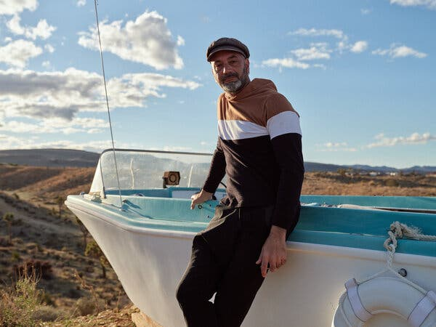
Alessandro Giuliano, the proprietor of the Desert Yacht Club, stands in front of one of the many boats on his nautically themed property.Credit...Cody James for The New York Times
“You put someone out in the desert in a fancy house with a big flat-screen TV and a fireplace on the screen instead of a real fire,” he said, standing in front of his empty Desert Yacht Club. “This is not what I moved here for.” He’s equally resentful of a new wave of visitors that seems to be more interested in mirrored glass and private pools than the desert itself.
Tensions over visitors, some of whom will, inevitably, want to claim a piece of the desert themselves, has been a part of the area’s story for years. But as the pandemic has boosted Joshua Tree’s allure for travelers, transplants and investors, it has magnified old conflicts and created new conundrums.
Desert lovers have long been renovating cabins and setting up glamping facilities for visitors. The pandemic has supersized that pattern, fueling a sort of gold rush through which investors from Los Angeles, New York, China and elsewhere are rushing in, not just to renovate properties, but to buy land to build homes explicitly for Airbnb and Vrbo.
The pace of growth is staggering. Demand for short-term rentals surged by 54 percent between 2019 and 2021, making Joshua Tree one of the top two fastest-growing markets in California and one of the top 25 fastest-growing markets in the United States, according to data from AirDNA, a company that collects and analyzes data from Airbnb and Vrbo. Joshua Tree and the nearby town of Yucca Valley issued 958 permits in 2021, more than nine times as many as they did in 2019, according to San Bernardino County and Yucca Valley data. As of March, there were 2,043 listings in Joshua Tree and Yucca Valley on Airbnb and Vrbo, more than twice as many as four years ago, according to AirDNA (1,818 are on Airbnb, though some are cross-listed).
Over the past two years, the price of the average home rose more in Joshua Tree and nearby Landers and Twentynine Palms than in any other part of California, according to an analysis by the San Francisco Chronicle. One Realtor who works in Joshua Tree said that plots are now selling for quadruple 2019 prices.
It’s the same story that has played out in destinations like Miami Beach, New York City and Barcelona, with a Mojave Desert twist. Yes, on social media and in public forums you’ll find similar debates about short-term rentals and rising rents. Recently, some parts of the region have begun requiring noise monitoring devices and capped the percentage of homes that can become short-term rentals — familiar moves from the managing-Airbnb playbook. But equally divisive is what all the construction and rules are doing to the beautifully odd trees and the spirit of the place.
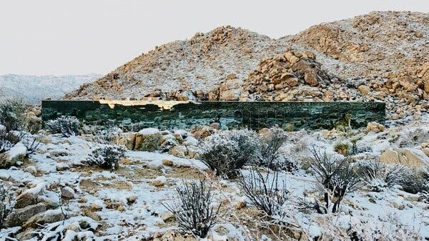
The “Invisible House,” above, is owned by Chris Hanley, a movie producer, who said he lives there when he’s not renting the place out to guests.Credit...Chris Hanley
“This is the future look of the American West,” said Chris Hanley, the producer of the movies “American Psycho” and “Spring Breakers,” who owns the Invisible House, a rectangular prism covered in mirrored glass that disappears into the landscape when viewed from the right angle. Unlike Mr. Giuliano, Mr. Hanley believes that modern architecture is good for the area’s creative evolution. For $3,000 to $6,000 a night, guests — who recently included the singer Demi Lovato and Brian Chesky, the chief executive of Airbnb — can swim in the indoor pool that stretches from the kitchen to the rear bedroom.
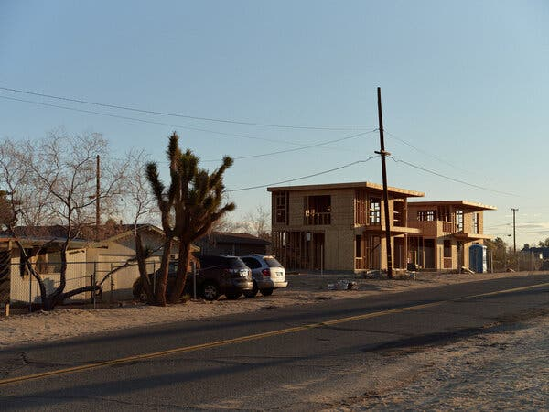
Corrugated iron fencing is a sign that something is a short-term rental. Chainlink fencing is a tip-off that it’s probably not.Credit...Cody James for The New York Times

How a $40,000 plot of land becomes short-term rental gold
I’m standing inside a nearly completed house destined for Airbnb that’s exuding strong villa-in-Bali energy. Or maybe it’s Tulum. It’s hard to believe that just two years ago this was an empty plot selling for around $40,000. If it wasn’t for the Joshua trees, their branches jutting out like characters in a Dr. Seuss book around the soon-to-be completed pool, I would not place us in the high desert.
“Wow, Joe, this is beautiful,” says J. Ovier Alvarez, a team leader for Coldwell Banker who sold Zhuo Zhang, a.k.a. Joe, the land, as we walk past an electric fireplace embedded in a wall of gray marbled tiles to the bedroom, which features a regal nine-foot-tall headboard. Mr. Alvarez had been driving me around the area when Mr. Zhang spotted us and invited us in.
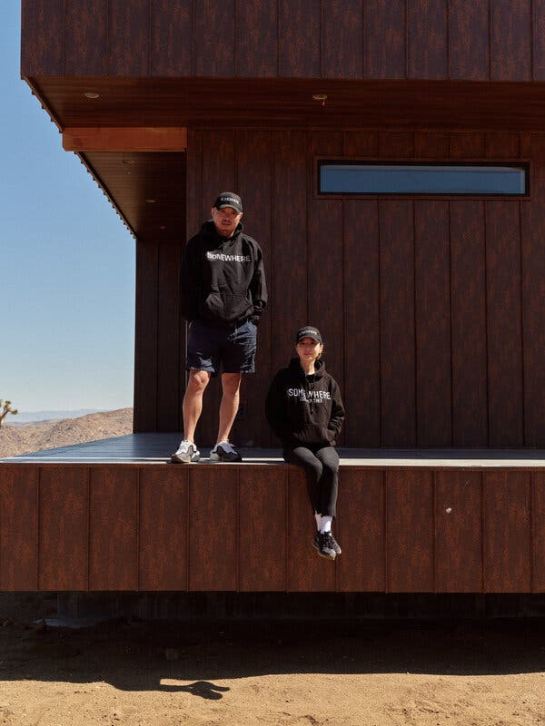
Through their property management and development company, Zhuo Zhang (“Joe”) and his sister, Yihong Zhang, will eventually own around 40 short-term rentals in the Joshua Tree area.Credit...Cody James for The New York Times
“We love art and architecture, you have the space for it here,” said Mr. Zhang a few days later as he and his sister, Yihong Zhang, showed us mock-ups for a new compound: four Airbnbs, each with its own pool, that will spell XOXO from above. We were standing inside “the floating box,” designed to appear as if it’s levitating. Once these and 31 other homes are completed, Somewhere, their property management and development company, will own around 40 rentals. The current nine, which go for $250 to $1,500 a night, are booked around 90 percent of the time.
This is impressive considering that just five years ago, the siblings moved to California from Shenzhen, China, without a clear plan, other than that they were ready to move on from advertising and commercial photography (him) and overseeing real estate matters for Walmart Asia (her).
But then they stumbled upon Joshua Tree. “It’s a good place to start our American dream,” Ms. Zhang said.
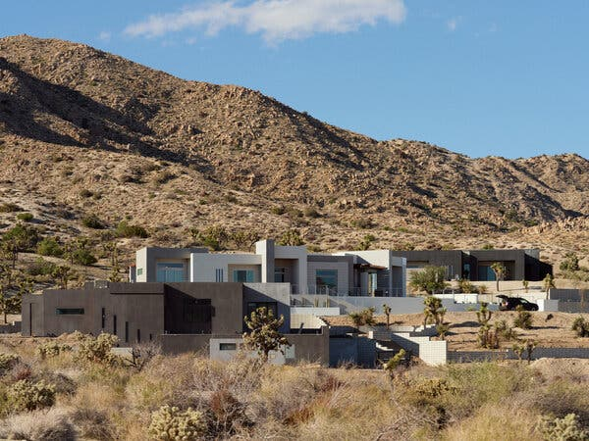
Modernist homes are filling some neighborhoods in the Joshua Tree region. Evoque Modern, the company that built the structures above, has begun turning down clients because there are too many investors who want any short-term rental that the company can build.Credit...Cody James for The New York Times

The rise of “high desert boho”
A dream also brought the Desert Yacht Captain to Joshua Tree. In 2013, the installation artist visited and became smitten with the idea of creating art in the desert. He liked that the land he purchased in 2014 lacked electricity or water hookups. He also liked that there were so many artists and musicians.
“It felt like there was a movement starting to take hold,” he said.
In fact, Joshua Tree has been drawing artists, musicians, architectural experimentalists, self-identified “weirdos” and others seeking inspiration and self-actualization for decades.
But part of what was different when Mr. Giuliano towed a 48-foot boat from Pismo Beach, Calif., to the top of his hill in 2016 was the way that many transplants were funding their dreams — by putting glamping setups or cabins on home-sharing websites. Quickly, Mr. Giuliano had more requests for his vintage trailers and canvas tents than he could handle.
Around that time, something else was changing that would set the stage for the rental gold rush: an appetite for an emerging aesthetic that some called “high desert boho” or “the Joshua Tree Look” on Instagram.
“In 2017 we started to feel like ‘wow, there is really something here,’” said Sara Combs, half of the husband-wife interior design duo behind The Joshua Tree House, a 1949 hacienda-style home about nine miles east of the Desert Yacht Club. The house, which they renovated in a palate of neutrals, now has more than 300,000 followers on Instagram, a store for “shopping your room” and spinoff inns in Tucson, Ariz., and soon, Marfa, Texas.
By 2018, there were so many renovated Joshua Tree rentals with the same metal cowboy tubs and wicker swings that an Instagram account emerged to mock them. Photos of these carefully curated spaces drew a new type of visitor, encouraging still more short-term rentals.
There was a sense, going into the pandemic, that this new desert economy could make dreams come true. You could come up with something weird or ultramodern, build it and get your money back through Airbnb, several developers said.
You could also move to the desert, build a stage next to a Joshua tree and start hosting free drive-in concerts after Covid canceled your violinist husband’s tour. Next thing you know you’d have 50 people there weekly, and, annoyingly, guests at a nearby glamping setup — the Desert Yacht Club — zooming by on your private road. This is what happened to Jacqueline Herrera, the owner of the Mon Petit Mojave ranch.

Shards in the dream
Inklings that the gold rush might be spiraling out of control came at different points for various players. Residents who complained about newcomers treating the desert like it was some kind of Wild West playground had been annoyed long before the rise of the Airbnb-Instagram economy. Stories of investors pushing out long-term renters — or sometimes squatters — had also been circulating.
But as the pandemic turbocharged development, it became harder to ignore these and other issues, like the fact that the new construction — paired with climate change and fires — threatened to drive the Joshua trees into extinction, said Brendan Cummings, the conservation director for the Center for Biological Diversity, which fights for imperiled species.
“Joshua Tree is booming because of the Joshua tree,” said Mr. Cummings, who successfully petitioned the California Fish and Game Commission to temporarily protect western Joshua trees under the state’s Endangered Species Act in September 2020. In June, the commission will decide whether to make the classification permanent. Several construction and real estate groups object to the policy, which requires obtaining a state permit before trimming, moving or building within 10 feet of a tree to avoid a $25,000 fine.
“Forty percent of Joshua trees are on private land,” said Mr. Cummings, a resident, who went years without fearing for the ubiquitous trees. But when science demonstrated that they were struggling as their habitat became a “cash cow,” his view shifted.
For Ms. Herrera, the problems became apparent the week that a “sculpture artist over in a yacht in the middle of the desert” sued her so that he and his guests could take a shortcut on a dirt road that runs across her 15-acre property.
The sculpture artist was the Desert Yacht Captain, Mr. Giuliano.
In hour five of a seven-hour open forum on short-term rentals in San Bernardino County held in February, I heard Ms. Herrera, 35, tell her story. Three weeks later, she stepped out of her Tesla and showed me the dirt road, which begins at a paved thoroughfare and leads up a rocky hill to the Desert Yacht Club.
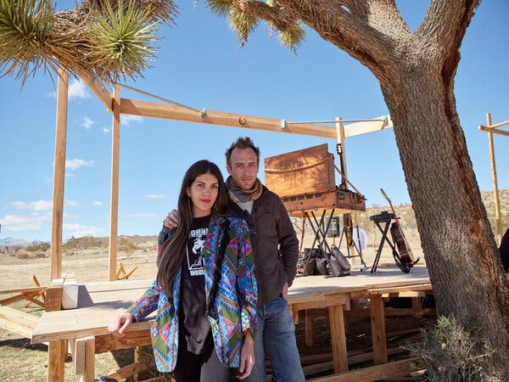
Jacqueline Herrera and her husband, Jeremie Levi Samson, are the owners of the Mon Petit Mojave ranch, where they host drive-in concerts. The use of their private road by guests from a nearby glamping site led to a lawsuit.Credit...Cody James for The New York Times
Initially, Ms. Herrera, who works in content marketing in Palm Springs, and her husband, Jeremie Levi Samson, a professional violinist from Paris, got along well with their Italian neighbor, who explained that he often used the road that ran along the border of their two parcels. He could continue to use it, Ms. Herrera told him.
But once the pandemic concert series started, Ms. Herrera realized that Mr. Giuliano’s 30 guests were also going to cross their land, sometimes in the middle of concerts.
“If it was just him, we wouldn’t have a problem,” she said. “But it’s all these party people coming and going and drinking. It’s chaos.”
In January of last year, after the Herreras began telling his guests they were trespassing, Mr. Giuliano sued them.
In some ways their conflict is typical of tensions throughout the region. San Bernardino County received just eight complaints involving short-term rentals in 2019. By 2020, that figure had skyrocketed to 439 before falling to 362 in 2021. Recent community meetings have been punctuated with stories about noisy visitors and overzealous residents threatening to show up with guns.
Suing his neighbors wasn’t personal, Mr. Giuliano explained when I tracked him down. In fact, instituting the procedure to get a prescriptive easement — or access to an unofficial road after you’ve consistently used it for five years — is not uncommon. It’s what a lawyer advised him, he said, since there is no official road to his property; even another route — a longer, circuitous path — requires trespassing, he said.
But then the couple countersued in February 2021, and that, said Mr. Giuliano, was when he realized that his desert dream might be over. He’d again have this suspicion when he was served with a property violation involving a New Year’s Eve party that his guests were planning. Another violation involving noise had come around the same time he’d gotten a letter from the county telling him that he needed a short-term rental permit or he’d be fined.
He was in a challenging situation, Mr. Giuliano said, because there is no clear-cut way to get a permit that allows for renting unconventional structures like trailers or even allowing guests to set up tents. Until the pandemic drove up complaints, no one enforced the rule, he said, something that the county confirmed.
Hundreds of other private campgrounds in the area are now in a similar predicament, according to Mason Smith, the head of government & community relations for Hipcamp, a sort of Airbnb for outdoorsy stays.
The county can’t permit tents, yurts and Airstream camps the same way they do houses because they raise the potential for “safety problems,” said David Wert, a spokesman for the county. “When someone sets up a bunch of teepees in the desert and invite people to stay there, where do they go to the bathroom?” he asked.
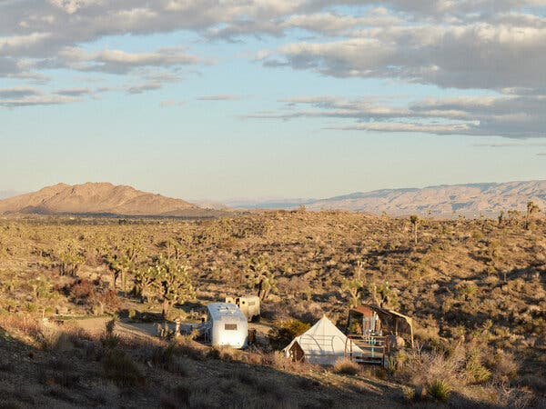
Some of the accommodations that Alesandro Giuliano used to rent out at his Desert Yacht Club. To satisfy newly enforced rules that prohibit renting most glamping setups, he’d have to disassemble the club and build a traditional house.Credit...Cody James for The New York Times

The root of the problem
The community is continuing to grapple with whether short-term rentals are helping or hurting the area. In early summer, San Bernardino’s board of supervisors is expected to announce modified rules. The county, which sets policies in Joshua Tree, is not expected to limit the percentage of housing stock that can become short-term rentals like the town of Yucca Valley recently did.
For its part, Airbnb says that short-term rentals give “residents a way to supplement their income, creating tens of thousands of jobs, and generating tax revenue statewide.” The company noted that since 2018, it has been collecting the 7 percent occupancy tax and handing it over to San Bernardino County. (Vrbo did not respond to a request for comment.)
But some, like Ms. Herrera, worry that luxury rentals are pushing out families and creating a “ghost town” feel.
Tonya Hansel, 36, who has been living in the area since she was 4, shares this concern. For the past eight years, she has been cleaning short-term rentals. She often works seven days a week to make ends meet. Still, when it comes to seeing her 14-year-old daughter, it’s better than her previous gig as a body piercer, she said.
But last month, she lost the thing that allowed her family to survive on $65 to $150 a cleaning: her $575-a-month rent.
In 2014, when she moved into her two-bedroom apartment on the north side of downtown Joshua Tree, there were only a handful of short-term rentals nearby, but they were in nicer neighborhoods.
But then investors began to see her neighborhood as prime lodging territory. At first, as renovators outnumbered heavy drug users, “it cleaned up the neighborhood,” she said. But then it became eerie as she realized that the families she used to run into were gone and that virtually every house was a short-term rental with “the same white, black and gray paint, shiny fence and fairy lights.”
These didn’t seem to be owned by the “jumble of artists and weirdos” — like her client Mr. Giuliano of the Desert Yacht Club. Rather they seemed to be owned by people who saw rentals as “easy money.”
In January, Ms. Hansel learned that her lease would be terminated in 60 days because her landlord was remodeling. It’s impossible to find a place, she said in February, as she began packing up, “because it’s either an Airbnb or it’s three times what I can afford.”
At the last minute, she found a temporary $800 one-bedroom in Landers, about 15 miles from Joshua Tree. It’s not ideal, Ms. Hansel said, noting that her daughter can no longer walk to school. But, she said, “we’re safe for now.”
Heather Murphy is a reporter on the Travel desk. She welcomes tips, questions and complaints about traveling during the pandemic. @heathertal

