NEWS

Plano has a short-term rental problem. Here’s what Arlington did to solve the same issue

Some residents want ordinances that prohibit the properties in Plano’s single-family residential districts.
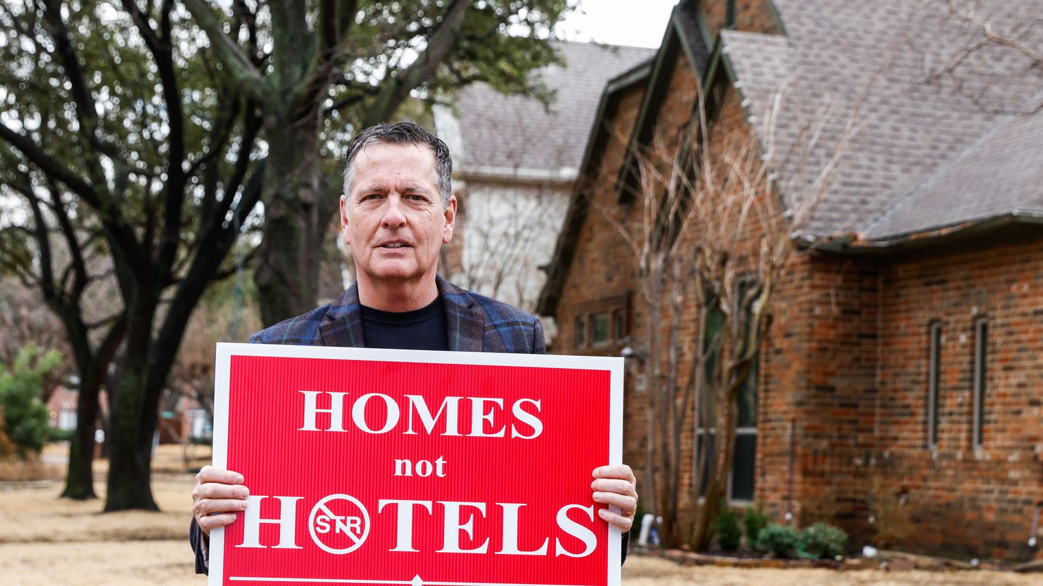
Bill France, the leader of the Plano Texas Neighborhood Coalition, poses for a portrait in Plano on Tuesday, Feb. 14, 2023.(Lola Gomez / Staff Photographer)
By Myah Taylor
6:25 AM on Feb 17, 2023
Bill France watched the house that once belonged to his longtime neighbor morph into a party destination.
The people who bought the home claimed it was a gift for their in-laws. France, a 26-year west Plano resident, didn’t think too much about the purchase.
“My wife talked to them and said (to me), ‘Well, the most you ever did was buy your in-laws a cup of coffee, you never bought them a house,’” France said.
The situation became less funny with time.
One day, France looked out his office window and witnessed a large frat-like party going on in the backyard next door.
“I said, ‘I don’t think that’s the in-laws having a party,’” France said.
His wife texted him a posting about the home on Vrbo, a website for vacation rentals. The listing said the property sleeps 16. Photos of the house featured pinball and foosball machines. The master bedroom closet had been converted to a bedroom.
“I was like ‘You’re not allowed to do that. This is Plano,’” France said.
ADVERTISING
Residents like France, the leader of the Plano Texas Neighborhood Coalition, have fought to prohibit short-term rentals (STRs) in the city’s single-family residential neighborhoods. Their goal is to adopt zoning ordinances similar to those in Arlington, where the rentals have successfully been prohibited in single-family residential districts.
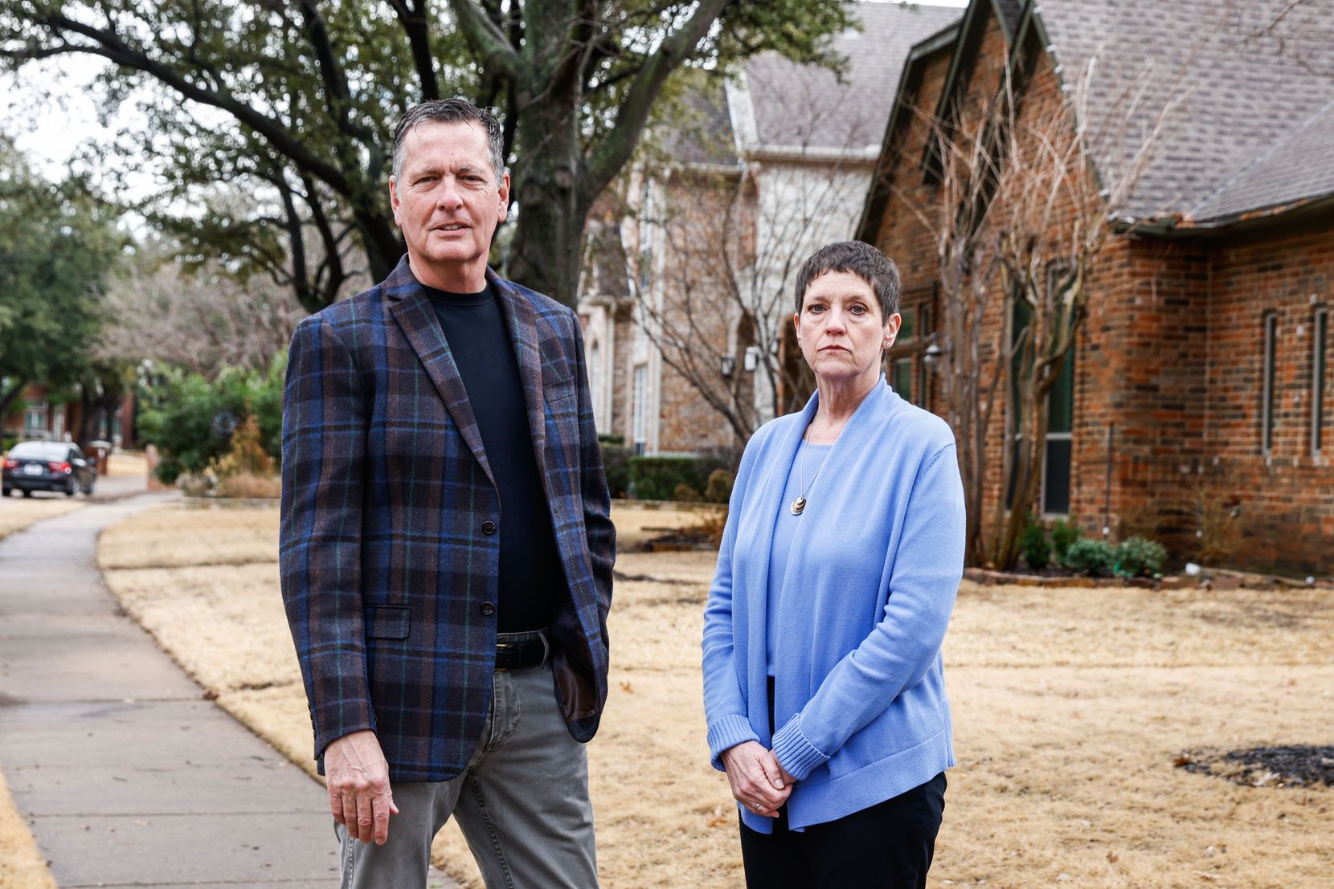Bill France, the leader of the Plano Texas Neighborhood Coalition, and coalition member Cindy Pattillo, pose together for a portrait in Plano on Tuesday, Feb. 14, 2023.(Lola Gomez / Staff Photographer)
Short-term rentals are residential properties rented for a period of less than 30 days through companies like Airbnb. The properties have cropped up in cities throughout the country.
In Dallas, nearly 6,000 STRs are listed, according to data from Inside Airbnb. Residents have fought to prohibit them throughout the city. Dallas is considering the “Keep it Simple Solution” that would ban short-term rentals from residential areas.
Plano community members say the non-owner-occupied properties operate like hotels and violate the city’s zoning ordinance laws. The city’s zoning ordinance says that all neighborhoods, with or without a homeowners association, are zoned residential districts. That zoning prohibits hotels, motels and bed and breakfasts in all single-family residential Plano districts.
Many members of the Plano TNC say they are concerned about noise, diminished safety, lack of available housing and the loss of community. About 600 Plano homes and counting are listed as short-term rentals, according to the chapter’s website.
“The problem that never goes away is the trepidation regarding what’s going to come next,” said Cindy Pattillo, a 30-year Plano resident who lives in the same neighborhood as France. “When I hear renters arrive, I wonder what impact are they going to have? How much noise are they going to make?
“Is this going to be a day where I’m going to have to call the police?”
In September, Dallas police busted a brothel operating out of a Plano short-term rental. Police arrested 23 men for their involvement in the sex trafficking ring that first began in a Dallas short-term rental before the operation moved to the Plano property.
Christina Day, Plano’s director of planning, told the city council on Jan. 23 that Plano police received 141 calls for service from Jan. 1, 2022 to Dec. 31, 2022. Those calls involved 57 short term rental properties. Six properties made up 41% of the calls for service.
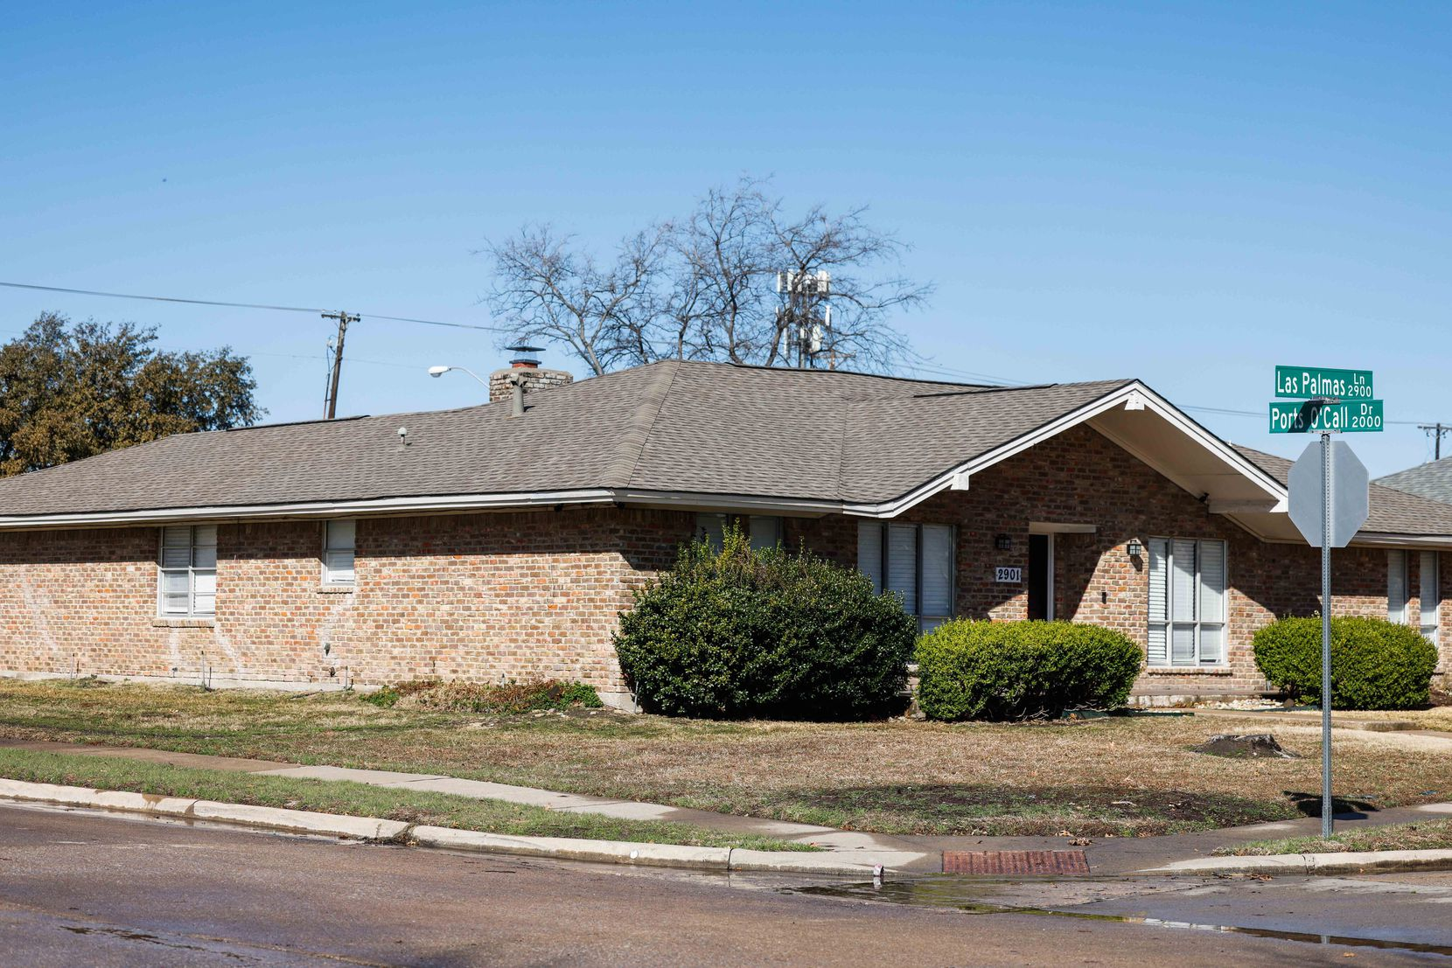Home in Plano on Tuesday, Feb. 14, 2023. In September 2022 Dallas Police shut down this short-term rental used as brothel.(Lola Gomez / Staff Photographer)
France sent an email to the city last March about his concerns. Christopher Smith, Plano’s property standards supervisor, responded in April that the city does”not have a specific ‘short-term rental’ ordinance,” according to screenshots of the email France provided to The Dallas Morning News.
“It is the position of the Attorney General of the State of Texas that cities cannot enact regulations to prohibit short-term rental activity because, according to the Texas Attorney General, it is an unconstitutional infringement on property owner rights,” Smith wrote in the email.
Smith said that the city had no plans to regulate the properties until it could adopt regulations that would be helpful for the community, adding that Plano was working with Airbnb to reduce listed properties causing frequent disturbance.
He said in the email that Plano entered an agreement with Airbnb and Home Away that allows it to collect local hotel/motel taxes from short-term rentals.

Following Arlington’s lead in the fight against short-term rentals
Last April, France started appearing at city council meetings to escalate the issue.
He then discovered the Texas Neighborhood Coalition, an organization founded by Dave Schwarte, a retired lawyer in Arlington. France started a Plano chapter that has grown to about 500 members.
Schwarte launched the statewide and Arlington initiative in May 2018 after he noticed short-term rentals multiplying around his home near AT&T Stadium.
Through Schwarte’s work, Arlington adopted two ordinances in April 2019. One prohibits STRs in single-family residential neighborhoods. The other enforces regulations for those operating the properties in designated areas.
With AT&T Stadium, Globe Life Field and Six Flags, Arlington is an entertainment center. The city said the short-term rentals could exist in that entertainment zone only.
Owners in Arlington must register short-term rental properties and obtain a permit for them, in addition to respecting other regulations.
“These ordinances in Arlington have become kind of the statewide model that many cities want to emulate, and they’ve worked,” said Schwarte, who works with TNC chapters across the state.
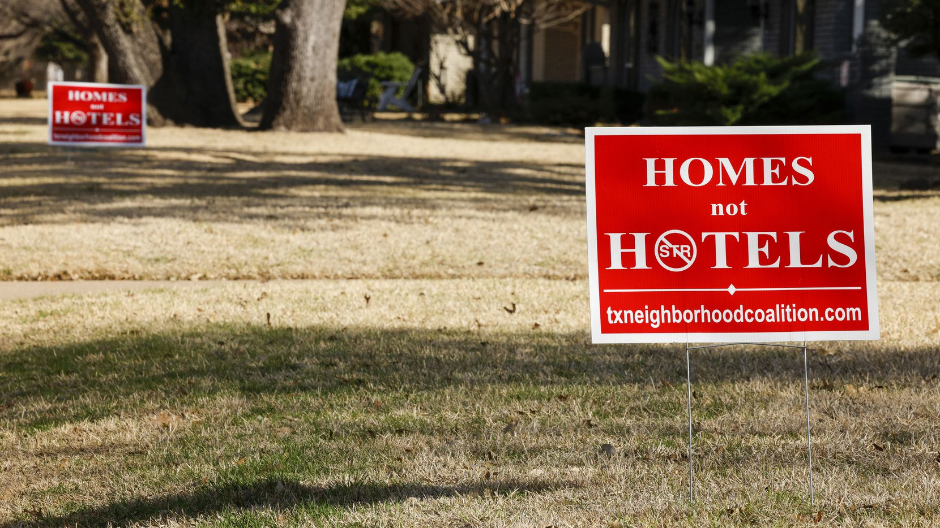Signs advocating against short-term rentals sit in the lawns of homes along Loma Vista Drive in North Dallas, Thursday, Jan. 19, 2023.(Elías Valverde II / Staff Photographer)
Schwarte said they expected legal challenges. The Fort Worth Court of Appeals upheld the ordinances. Then, short term rental advocates took the case to the Texas Supreme Court, which rejected the appeal in January 2022. A civil suit filed by short-term rental companies against Arlington was dismissed with prejudice in December, meaning the plaintiffs can’t challenge the ordinances again.
“Our experience belies the argument that you hear from the short-term rental folks that says cities don’t have the power to protect single-family residential neighborhoods,” Schwarte said.
France and other residents hope Plano uses a similar template as Arlington.
Plano officials said at the Jan. 23 city council meeting that staff has worked to develop a short-term rental registration program and has gathered data from other cities, like Austin and Arlington.
“Until we get that completed, we won’t have a decision on which direction we want to go, but that will be forthcoming in the early part of the summer,” Plano Mayor John Muns told The News.
France said he is cautiously optimistic about future restrictions because he feels the city only recently started to take the issue seriously.

Plano proceeding with caution
If Arlington is the model, Austin is the cautionary tale.
The capital city is Texas’ hotbed for short-term rentals with numbers ranging up to over 13,000 in the city limits, according to data from Inside Airbnb. East Austin has been rife with party houses like the ones France and Patillo see in their neighborhood. In addition to the nuisance residents say short-term rentals cause, others say the presence of these properties contributes to rising housing costs in Austin.
Plano TNC wants the city to take action soon, but Plano officials are cautious. Austin passed a short-term rental ordinance in 2016 that banned STRs at non-owner occupied houses, but then faced pushback from Texas courts prioritizing property rights.
The Texas Supreme Court ruled the ordinances unconstitutional saying they violated the right to peaceably assemble on private property. In May 2018, the court ruled against HOA enforcement of short-term rentals.
If Plano doesn’t get its ordinances right, the city could face the same legal troubles, the mayor said.
“We’ll use that (collected) data to make a decision that will not only protect property rights, but also protect folks from having problems with the outside renters,” Muns said.
Plano could also struggle to regulate the properties if not careful.
Arlington, Schwarte said, determined the designated areas where short-term rentals could operate before instituting the registration process. Austin did not, licensing the short-term rentals before deciding where they could operate.
“If you license a short-term rental … for any period of time you may have a very difficult time as a city shutting down the operation,” Schwarte said.
Schwarte said Plano almost made the same mistake. The city published proposed legislation in November that would require short-term rentals to register, but it didn’t say where they could operate.
The proposal could be interpreted as allowing short-term rentals to exist in areas zoned as single-family residential districts. On behalf of TNC, Schwarte wrote in a letter to Plano’s City Council that the action would violate the Texas Local Government Code and the Plano zoning ordinance.
Plano changed course, but protecting property rights still remains on the city’s conscience.
Community members wonder about who is considering their rights.
“In one of the prior meetings, they expressed a concern about being sued,” Pattillo said. “... If it takes getting sued to solve this problem … and to ensure that Plano continues to be the ‘City of Excellence,’ then that may just be a step in the process.”
Myah Taylor, Collin County Reporter. Myah Taylor covers Collin County with emphasis on Plano. She formerly worked as a fall sports intern covering high school football for The Dallas Morning News. Taylor is a 2022 graduate of the University of Texas at Austin. Before arriving in Dallas, she held internships with the Austin American-Statesman, Yahoo Sports and the Los Angeles Times.
myah.taylor@dallasnews.com t_myah

