June 15, 2023

Texas Neighborhood Coalition (TNC) has superb news to report. After a four-year battle to protect neighborhoods, the Dallas Chapter succeeded last night in persuading their City Council to pass an ordinance excluding short-term rentals from all single-family zoned neighborhoods. Please see the Fox4 report of today below. And the margin of victory was a convincing 12 to 3.

The Dallas Chapter’s success is a textbook case of how ordinary citizens can beat multi-billion-dollar corporations when they organize, are well lead, speak up in great numbers, and never give up. It is a lesson that citizens in other cities across Texas would benefit from heeding. And some city councils can certainly learn from this.

We hasten to add that this great victory for neighborhoods in Dallas could not have been possible if so many TNC members and other neighborhood groups had not been very active in defeating the wrong-headed STR preemption bills in the 2023 legislative session. So, TNC members and our allies should take a virtual bow.

https://www.fox4news.com/news/dallas-short-term-rentals

Dallas City Council bans short-term rentals from single-family areas
Dan Godwin June 15, 2023 6:24AM

Dallas votes to restrict short-term rentals
After a day of debate the Dallas City Council voted late Wednesday night to add restrictions for short-term rentals, like Airbnb and Vrbo. The council decided to ban short-term rentals from neighborhoods with single family homes.
DALLAS - After a day of debate the Dallas City Council voted late Wednesday night to add restrictions for short-term rentals, like Airbnb and Vrbo.
The council voted on the issue a little before midnight, after more than four hours of testimony from dozens of people on both sides of the emotional issue.
The council decided to ban short-term rentals from neighborhoods with single family homes.
STRs will still be allowed in neighborhoods with multi-family dwellings and commercial zones.
However, the council added new restrictions.
STR properties must register with the city each year and pay the same kinds of taxes and fees that hotels pay to operate.
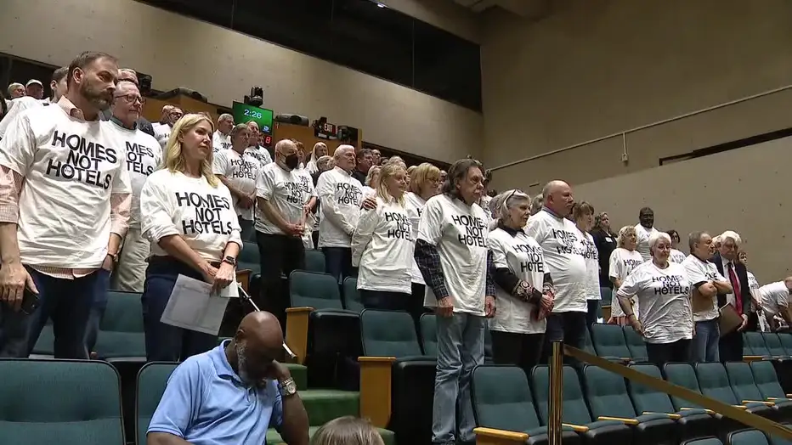
Many Dallas residents have spent years asking for these kinds of changes saying that rental properties bring crime and noise to their neighborhoods.
READ MORE: Drive-by shooting at Dallas short-term rental leaves neighbors terrified
"I see both sides of this but to those asking if STRs should be allowed. Is your money more important than our safety and sanity?" said Thomas Hitchcock, who lives near an STR.
STR owners argued that limiting the rentals would lead to severe financial hardship for some owners.
"There's a way that we can protect these neighborhoods and these great homeowners while still finding a way to keep the tax revenue, the tourism revenue the job creation that that short-term rentals can bring to the city," said Timothy Kirby, who owns an STR.
The new rules will also require rental properties to follow noise and limit the number of occupants to 12.
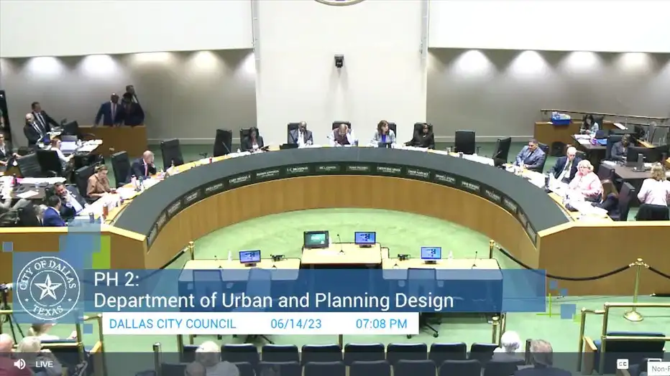
Enforcement of the new regulations won't kick in until December to allow property owners time to phase out STRs in single-family neighborhoods and for the city's code enforcement to prepare as well.
In a narrow 8-7 vote the council opted not to exempt currently-operating STRs from the new rules.
About 1,000 STRs are currently registered in single-family areas in the city.
Those close to the city say that lawsuits are already being filed.

