SPEAKERS ON STR SOLUTIONS AT THE DALLAS CITY COUNCIL MEETING – 03/09/2022
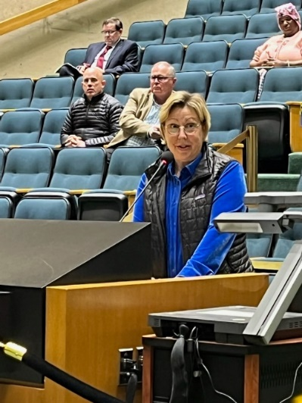
Olive Talley, Ed Zahra and Tom Forsyth with the Dallas Neighborhood Coalition appeared before the Dallas City Council at its Open Mic Session before the Council Meeting on March 9, 2022. Here are excerpts of their remarks on Dallas STR Solutions:
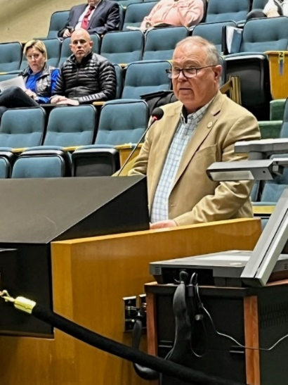
Olive Talley’s Remarks on Dallas STR Solutions:
I’m Olive Talley, 6133 Prospect Ave., in District 14, where we have the highest concentration of STRS in the city.

I am part of a growing group of neighborhood leaders across the city -- representing thousands of your constituents – who have been working for more than two years to protect
neighborhoods from the misery of STRs.

We come to you now with one simple ask. Enact proactive zoning measures and then strong regulations – in that order.

Expedite a process that began three months ago at CPC to align the tax code with the development code in defining STRs.

Our STATE and LOCAL TAX CODES already define Short Term Rentals as LODGING USES. That’s why they pay Hotel Occupancy Taxes. Legally they function like HOTELS. BUT OUR RESIDENTIAL DISTRICTS DO NOT ALLOW LODGING USES.

This is a simple fix and need not take a long time. Update the code to include short term rentals as a lodging use. It’s really that easy.

This City Council has the full legal authority to regulate STRS through zoning. Texas courts have affirmed this power as long as it is done the right way. And the right way is to follow state law that requires council to get a recommendation from CPC to update zoning laws.

That process is already underway. In early December, CPC voted nearly unanimously to authorize a public hearing to consider defining a short-term rental as a new lodging use.

And the Quality-of-Life Committee voted unanimously to brief you in April, with the intent of sending this to CPC. We support that.

So, take the next step: Instruct the city manager to expedite this work by ZOAC and CPC.

IF you rush to enact ANY Regulations before you clarify the zoning, you risk falling in the same legal trap that Austin fell into a decade ago. Don’t repeat their mistakes. Avoid them.
This solution is long overdue.

Let’s learn from other cities and protect our neighborhoods. I respectfully ask that you take the next step toward a solution by expediting the zoning process.

Thank you for your service and for allowing me this opportunity to speak to you today.

Olive Talley
Edgemont Park Conservation District

Ed Zahra’s Remarks on Dallas STR Solutions:
Good morning, Mayor Johnson, City Council members

You will soon be briefed on a policy to manage the explosive growth and operation of Short-Term Rental (STR) HOTELS within the City of Dallas.

The Task Force regulations only describe the registration and compliance process but have ignored the most important issue: Where STRs are allowed to legally operate. If passed, they will create a de facto amendment to the zoning ordinance that will allow STR HOTELS to continue to operate in Single-Family zoned neighborhoods without action by the CPC.

I believe that the City Council should ask the CPC to act first on a modification to the definition of Lodging in the City Development Code.

1. Existing SEC.51A-4.205 (1) (A) Definition of LODGING USES states: “A facility containing six or more guest rooms that are rented to occupants on a daily basis.”

2. Proposed CPC action is to add to the definition of Section (1) (A) this statement: “A Short-Term Rental (STR) facility containing one or more guest rooms that are rented to occupants for 30 days or less.”

This is an equitable revision to SEC.51A-4.205 which will clarify which zoning districts STR Hotels can legally operate in the City of Dallas. It will also align the Development Code with the State and City Tax Code which defines STR properties to be hotels and therefore subject to the Hotel Occupancy Tax (HOT).

Please also note: SEC.51A-4.112. SINGLE-FAMILY DISTRICTS: Purpose. This district is intended to be composed of single-family dwellings together with public and private schools, churches, and public parks essential to create basic neighborhood units. (B) Commercial and business service uses. NONE PERMITTED.

Our zoning ordinances ensure managed, predictable growth by creating defined land use. Zoning also allows citizens to choose where they want to live based on a Quality Of Life that is expected and protected.

You have full legal authority to regulate where STR Hotels may legally exist and where they may not without interfering with any owner property rights.

Please enforce our zoning laws to save our Single-Family neighborhoods. You and your family are not immune to the misery your constituents are facing.

Ed Zahra, 1003 Valencia, Dallas TX 75223.
Hollywood/Santa Monica Neighborhood

Tom Forsyth’s Remarks on Dallas STR Solutions:
I am Tom Forsyth and reside at 2115 Siesta Drive. I am here to discuss SHORT TERM RENTALS, which can now operate anywhere in the city, and without regulation. You have two tasks before you to solve this problem: the first is zoning and the second is policy. Eighteen Texas Cities have enacted both zoning and regulatory frameworks. Arlington and Ft. Worth put zoning amendments in place first and then ratified STR regulations. Ft. Worth was not brought into court. Arlington won in court. Austin passed ordinances first before zoning and they did not fare as well. Your city attorneys will confirm these facts.
These cities have zoned STRs out of single-family neighborhoods. Why? Our state and local tax codes define Short Term Rentals as LODGING uses. The city collects HOT taxes as a result. In our Development Code, LODGING uses are not allowed in residential districts. LODGING is defined on page 206 of the Dallas City Code (see chart) as Hotels, Motels, Boarding Houses and Overnight Stays. The city does not allow Hotels to operate in our neighborhoods and it should not allow STRs to exist next door to families. The fix that you can make is quite simple: Add STRs to this chart. Please ask Zoac and the CPC to add STRs to the definition of LODGING as an excluded land use in residential areas.
The next part of your job is to produce regulations that will ensure responsible STR operation where they are allowed to exist. First, require STRs to obtain a business permit to operate and undergo inspections, just like a hotel. Then put in place guest maximums of 10 or 12 and make STRs provide onsite parking for guests. Please don’t allow outdoor assembles, outdoor sound equipment and event venues on these properties especially at night. STRs should operate like hotels. They are for sleeping, not for partying.
It should be mandatory for STR platforms to provide you with auditable data on listings and transactions. License revocation should be after two after 2 incidents in a year or one criminal violation.
Every day that passes brings more problems caused by STRs and higher enforcement costs to the city. STR properties take housing away from families who want to live here and increase the cost of the houses that are available. They result in a loss of community as neighbors are replaced by a revolving door of strangers. You have an obligation to protect and serve the residents of the City of Dallas who deserve to live in peaceful and quiet neighborhoods. Would you want to live next to one? If not, then why allow this practice to continue? Please put an end to STR hotels in neighborhoods! Thank you!
Respectfully,
Tom Forsyth
President, Oak Park Estates Neighborhood Association (OPENA)

